AN INTELLIGENT SPACE UTILIZATION ANALYTICS PLATFORM
FOR RESOURCE OPTIMIZATION
PROJECT REPORT
Submitted by
SHASVIN D
VIVIN C
SATCHINDRA R B
In partial fulfilment for the award of the degree
of
BACHELOR OF TECHNOLOGY
in
INFORMATION TECHNOLOGY
and
ARTIFICIAL INTELLIGENCE AND DATA SCIENCE
BANNARI AMMAN INSTITUTE OF TECHNOLOGY
(An Autonomous Institution Affiliated to Anna University, Chennai)
SATHYAMANGALAM - 638401
ANNA UNIVERSITY: CHENNAI 600 025
OCTOBER 2026

BONAFIDE CERTIFICATE
Certified that this project report “An Intelligent Space Utilization Analytics Platform for Resource Optimization” is the Bonafide work of "SHASVIN D (7376242IT295), VIVIN C (7376242AD344), and SATCHINDRA R B (7376242AD296)" who carried out the project work under my supervision.
The work presented in this report was completed as part of the requirements for the course S5 Mini Project during the academic year 2026–2027. The empirical data, system design, implementation workflows, security mechanisms, and verification results presented in this report represent their genuine work.
SIGNATURE  Dr. C. POONGODI  HEAD OF THE DEPARTMENT  Department of Information Technology  Bannari Amman Institute of Technology  Sathyamangalam - 638401 | SIGNATURE  K. R. SABARMATHI  ASSISTANT PROFESSOR  Department of Information Technology  Bannari Amman Institute of Technology  Sathyamangalam - 638401
Submitted for Project Viva Voice examination held on ………………………………
Internal Examiner I | Internal Examiner II

DECLARATION
We affirm that the project work titled “An Intelligent Space Utilization Analytics Platform for Resource Optimization” being submitted in partial fulfillment of the requirements for the award of the degree of Bachelor of Technology in Information Technology (for Shasvin D) and Bachelor of Technology in Artificial Intelligence and Data Science (for Vivin C and Satchindra R B) is the record of original work done by us under the guidance of K. R. Sabarmathi, Assistant Professor, Department of Information Technology. It has not formed a part of any other project work(s) submitted for the award of any degree or diploma, either in this or any other University.
We further declare that this work has not formed the basis for the award of any other degree, diploma, associateship, or fellowship previously. All primary sources, literature citations, software libraries, and empirical data sets utilized during this study have been dutifully cited in the References.
SHASVIN D  (7376242IT295) | VIVIN C  (7376242AD344)
SATCHINDRA R B
(7376242AD296)
I certify that the declaration made above by the candidates is true.
(Signature of the Guide)
K. R. Sabarmathi, M.E., (Ph.D.)
Assistant Professor, Department of Information Technology

ACKNOWLEDGEMENT
First and foremost, we thank the Almighty for giving us the strength, guidance, and perseverance to successfully execute and complete this academic project.
We express our profound gratitude to our esteemed Chairman Dr. S.V. Balasubramaniam, and the respected Principal Dr. C. Palanisamy for providing excellent facilities, institutional computing infrastructure, and support during the course of study in this institute.
We are grateful to Dr. C. POONGODI, Head of the Department, Department of Information Technology for her valuable suggestions, administrative encouragement, and support to carry out the project work successfully.
We wish to express our sincere thanks to our respected Project Guide, K. R. Sabarmathi, Assistant Professor, Department of Information Technology, for her constructive ideas, inspirations, encouragement, excellent guidance, and much needed technical support extended to complete our project work.
We would like to thank our friends, faculty members, and lab technicians who have directly and indirectly contributed to the success of this project.
SHASVIN D (7376242IT295)
VIVIN C (7376242AD344)
SATCHINDRA R B (7376242AD296)

ABSTRACT
Efficient physical infrastructure management is one of the most critical operational challenges in contemporary higher education institutions. Campus room allocation workflows often suffer from operational opacity, frequent scheduling collisions, and chronic underutilization of expensive facilities. This project presents the design and full-stack implementation of an Intelligent Space Utilization Analytics Platform for Resource Optimization, developed for the S5 Mini Project at Bannari Amman Institute of Technology.
Built on a responsive full-stack web architecture using Node.js, Express.js, MySQL 8.0, and vanilla JavaScript (ES6+), the system replaces manual logbooks with a centralized, real-time institutional platform managing 20 campus facilities distributed across four distinct campus blocks (Block A, Block B, Block C, Block D), encompassing 10 classrooms, 6 high-performance laboratories, and 4 seminar halls.
The system architecture provides role-based workspaces for three distinct institutional stakeholders: System Administrators (space management, booking request adjudication, faculty provisioning, audit logs), Faculty Members (live space discovery, multi-criteria filtering by block, type, and capacity, reservation request submission), and Campus Management (macro-level utilization metrics, space-type efficiency analytics, block-by-block occupancy distributions, and timetable schedules).
A core highlight of the developed system is its Unified Campus Utilization and Space Optimization engine. It delivers proactive underutilization alerts (<50% usage) to help administrators balance institutional workloads, while providing granular daily, weekly, monthly, and Block-wise schedule views. Furthermore, an automated background job monitors completed sessions and immediately releases rooms back to the available pool upon class completion. Security is maintained through 10-round salted bcryptjs hashing, parameterized query defense, and immutable audit logging.

Table of Contents
CHAPTER NO. | TITLE | PAGE NO.
 | ACKNOWLEDGEMENT | I
 | ABSTRACT | II
 | TABLE OF CONTENTS | III
 | LIST OF TABLES | IV
 | LIST OF FIGURES | V
1 | INTRODUCTION | 10
1.1 | Background of the Work | 10
1.2 | Problem Statement and Motivation | 10
1.3 | Scope of the Work | 11
1.4 | Objectives of the Study | 11
1.5 | Methodology Overview | 12
2 | LITERATURE SURVEY | 13
2.1 | Overview of Space Management Studies | 13
2.2 | Comparative Analysis & Research Gap | 13
3 | PROPOSED METHODOLOGY | 15
3.1 | Hardware and Software Technology Specifications | 15
3.2 | Campus Space Inventory & Distribution | 16
3.3 | Limitations of Traditional Space Allocation Methodologies | 16
3.4 | Multi-Tier Web System Architecture | 17
3.5 | Space Booking, Collision Validation & Approval Workflow | 17
3.6 | Automatic Space Release & Availability Lifecycle | 18
3.7 | Database Schema & Relational Entity Model | 19
3.8 | Database Security Hardening & Principle of Least Privilege | 22
3.9 | System Module Implementation & User Interfaces | 23
4 | RESULTS AND ANALYSIS | 27
4.1 | System Testing & Functional Verification Matrix | 27
4.2 | Database Security & Hardening Verification | 28
4.3 | Functional Achievements & Operational Velocity | 29
4.4 | Space Optimization Analytics & Utilization Impact | 29
4.5 | Operational Performance and Discussion | 29
5 | CONCLUSION AND FUTURE WORK | 30
5.1 | Conclusion | 30
5.2 | Architectural Advantages & Departmental Impact | 30
5.3 | Future Enhancements | 30
6 | REFERENCES | 32
7 | APPENDICES | 33
8 | PLAGIARISM REPORT | 35

List of Tables
S NO. | TABLE NAME | PAGE NO.
3.1 | Hardware Specification & Minimum Requirements | 15
3.2 | Full-Stack Software Technology Specifications | 15
3.3 | Campus Space Distribution Across Blocks A, B, C, D | 16
3.4 | Comparative Inefficiency Matrix: Manual vs. Automated System | 16
3.5 | Data Dictionary: users Table (Authentication & Roles) | 19
3.6 | Data Dictionary: spaces Table (Campus Facilities Inventory) | 20
3.7 | Data Dictionary: requests Table (Space Booking & Scheduling) | 20
3.8 | Data Dictionary: audit_logs Table (Immutable Security Audit Trail) | 21
3.9 | 3-Layer Security Architecture Configuration | 22
3.10 | User Interface Architecture & Specifications Matrix | 23
4.1 | Functional Test Cases and Verification Results (TC01–TC14) | 27
4.2 | Database Security & Hardening Verification (SEC01–SEC06) | 28
7.1 | Research Dissemination & Publication Record | 34
8.1 | Institutional Plagiarism Clearance Verification | 35

List of Figures
S NO. | FIGURE NAME | PAGE NO.
3.1 | Multi-Tier Web System Architecture | 17
3.2 | Space Booking, Collision Validation & Approval Workflow | 18
3.3 | Database Entity Relationship (ER) Diagram | 19
3.4 | Unified Authentication & Secure Login Portal | 23
3.5 | System Administrator Control Center & Real-Time KPIs | 24
3.6 | Campus Space Inventory & Facility Management Interface | 24
3.7 | Faculty Space Discovery & Multi-Criteria Filtering Interface | 24
3.8 | Modal Interface for Booking Request Submission | 25
3.9 | Management Executive Occupancy Analytics Dashboard | 25
3.10 | Unified Campus Utilization & Block-wise Schedule Matrix | 25
3.11 | Security Posture Badges & Immutable Database Audit Trail | 26

CHAPTER 1- INTRODUCTION
1.1 BACKGROUND OF THE WORK
In contemporary educational institutions, physical campus infrastructure represents one of the largest capital and operational investments. The efficient scheduling, allocation, and utilization of physical spaces—encompassing lecture halls, specialized computer laboratories, seminar halls, and smart classrooms—directly impacts institutional productivity, student learning outcomes, and administrative overhead.
In traditional university environments, physical room allocations are managed using fragmented, manual, or spreadsheet-driven procedures. Decentralized booking workflows across academic departments lead to operational opacity, frequent scheduling collisions, double bookings, and severe capacity underutilization. Faculty coordinators spend significant administrative time cross-checking availability, negotiating room swaps, or resolving last-minute room disputes.
The Intelligent Space Utilization Analytics Platform for Resource Optimization is engineered to overcome these fundamental systemic hurdles. Built on a responsive, lightweight full-stack architecture using Node.js, Express.js, MySQL 8.0, HTML5, CSS3, and modern JavaScript, the platform acts as an automated campus control center. It integrates role-based booking requests, dynamic collision prevention, real-time space release mechanisms, space optimization alerts, and verifiable database audit logging into a unified institutional portal.
EXECUTIVE SUMMARY
The implemented platform is fully functional, prevents room scheduling clashes through server-side validation, improves facility occupancy visibility, and provides verifiable administrative accountability.

1.2 PROBLEM STATEMENT AND MOTIVATION
Manual and spreadsheet-based campus room allocation methods create severe administrative liabilities for modern academic institutions:
1. Information Asymmetry: Faculty members lack real-time visibility into actual room occupancy, resulting in underutilized spaces while adjacent facilities remain oversubscribed.
2. High Collision Probability: Booking requests processed through disconnected channels (paper requisition forms, email, instant messaging) lead to overlapping reservations for the same facility and time slot.
3. Chronic Space Underutilization: While certain popular lecture halls operate near capacity, specialized laboratories and auxiliary seminar rooms experience extensive idle periods without administrative awareness.
4. Zero Accountability & Audit Trail: Traditional databases often operate under root privileges without tracking administrative approvals, credential changes, or failed access attempts.
1.3 SCOPE OF THE WORK
The project scope encompasses 20 campus facilities categorized into 10 classrooms, 6 computer laboratories, and 4 seminar halls distributed uniformly across four campus blocks (Block A, Block B, Block C, Block D). The platform delivers specialized, secured web portals for three institutional user classes:
• System Administrators: Complete room inventory lifecycle, approval/rejection of reservation requests, faculty account management, and security audit inspection.
• Faculty Members: Real-time room discovery, multi-criteria filtering by block, space type, and capacity, and instant booking submission with immediate validation.
• Campus Management: High-level institutional occupancy analytics, space type utilization comparisons, block-wise utilization matrices, and room optimization alerts.
1.4 OBJECTIVES OF THE STUDY
The primary objective of this project is to develop, test, and deploy a robust full-stack campus room management platform with the following specific goals:
1. Centralized Facility Governance: Manage 20 campus facilities across 4 campus blocks with detailed metadata (block, capacity, space type, operational status).
2. Dynamic Collision Prevention: Enforce server-side validation rejecting overlapping time intervals on approved space requests.
3. Unified Utilization & Optimization Analytics: Provide campus administrators with proactive underutilization alerts (<50% usage) and granular block-wise schedules.
4. Automatic Facility Release: Deploy an automated background scheduler that releases facilities back to 'Available' status once the reservation window has elapsed.
5. 3-Layer Enterprise Database Security: Implement 10-round salted bcryptjs password hashing, strict parameterized SQL statements, dedicated restricted MySQL user credentials, and immutable audit logging.
1.5 METHODOLOGY OVERVIEW
This report is organized into five comprehensive chapters. Chapter 1 introduces the background, problem statement, objectives, and scope. Chapter 2 presents a critical literature review of campus space management and algorithmic scheduling. Chapter 3 details the proposed methodology, encompassing hardware/software specifications, campus space inventory, multi-tier web architecture, collision prevention, auto-release engine, database schema, and module implementations. Chapter 4 provides the results and analysis, including functional test cases (TC01–TC14), database security verification (SEC01–SEC06), and occupancy analytics. Chapter 5 concludes the report and discusses future enhancements. References, appendices, and institutional plagiarism clearance are appended thereafter.

CHAPTER 2- LITERATURE SURVEY
2.1 OVERVIEW OF SPACE MANAGEMENT STUDIES
The optimization of educational space utilization and academic timetabling has been extensively investigated across operations research, facilities management, and computer science literature. Recent studies emphasize the growing necessity for data-driven, real-time spatial governance in universities:
[1] Lavy, Daneshpour, and Choi (2020) investigated spatial utilization across university academic facilities, establishing that higher education facilities frequently suffer from structural underutilization (averaging 40–55% occupancy) due to departmental silos and lack of cross-faculty sharing mechanisms.
[2] Valks et al. (2021) conducted an extensive longitudinal study on university campus space utilization, demonstrating that dynamic space allocation technologies and real-time dashboard visibility can elevate facility efficiency by up to 25% without requiring new physical construction.
[3] Dunke and Nickel (2023) formulated a customized matheuristic framework for university course timetabling, highlighting the mathematical complexity of multi-criteria space scheduling under hard room capacity constraints and conflicting faculty time preferences.
[4] Chen, Werner, and Shokouhifar (2023) developed mathematical modeling approaches for university course scheduling, illustrating that automated conflict-detection algorithms substantially decrease human scheduling errors and administrative resolution delays.
[5] Davison, Kheiri, and Zografos (2025) formulated an advanced integer programming model solving the university timetabling problem under hybrid learning paradigms, establishing that automated schedule rebalancing mitigates room contention during peak teaching hours.
CONTRIBUTION TO STATE-OF-THE-ART
Our proposed platform addresses these exact deficiencies by combining real-time server-side collision validation, automated background space recovery, underutilization alerts, and an institutional 3-layer database security framework.

2.2 COMPARATIVE ANALYSIS & RESEARCH GAP
A rigorous comparative review of contemporary literature reveals three critical operational and technical research gaps in higher education room governance:
1. Theoretical vs. Operational Disconnect: Prior literature has primarily focused on offline mathematical optimization models, which are incapable of handling ad-hoc daily booking requests or real-time room reservations.
2. Neglect of Database Security & Governance: Existing academic prototypes routinely overlook fundamental security hygiene—operating with unhashed credentials, administrative over-privileging, and vulnerable string-concatenated SQL queries.
3. Absence of Automated Space Release Lifecycles: Conventional room reservation systems fail to actively monitor reservation elapsed times, requiring manual check-out workflows that result in phantom occupancy.

CHAPTER 3 - PROPOSED METHODOLOGY
3.1 HARDWARE AND SOFTWARE TECHNOLOGY SPECIFICATIONS
The developed space management platform is engineered for high operational velocity, cross-browser compatibility, and zero client-side installation overhead. Table 3.1 details the hardware specifications and Table 3.2 outlines the full-stack software technology stack.
Table 3.1: Hardware Specification & Minimum Requirements
Component | Minimum Requirement | Recommended Specification
Central Processor (CPU) | Dual-Core 2.0 GHz x64 | Quad-Core Intel i5 / AMD Ryzen 5 (2.8 GHz+)
System Memory (RAM) | 4 GB DDR3/DDR4 | 8 GB / 16 GB DDR4 high-speed RAM
Storage Subsystem | 10 GB free disk space (HDD) | 256 GB NVMe SSD for fast query caching
Network Interface | 100 Mbps Ethernet adapter | Gigabit LAN / IEEE 802.11ac Wi-Fi
Client Hardware | Standard Desktop / Mobile display | Full HD (1920x1080) monitor / Touch device

Table 3.2: Full-Stack Software Technology Specifications
Layer / Category | Technology Selected | Version | Architectural Purpose
Operating System | Microsoft Windows / Linux | Win 10/11 / Ubuntu | Host operating system environment
Runtime Environment | Node.js (V8 Engine) | v18.x / v20.x LTS | Asynchronous non-blocking I/O execution
Backend Framework | Express.js | v4.18+ / v5.x | REST API routing, middleware, error handling
Relational Database | MySQL Community Server | 8.0.x / 8.4 LTS | ACID transactional persistent storage
Database Driver | mysql2 (Connection Pool) | v3.9+ | Prepared statement caching & pooling
Password Cryptography | bcryptjs | v2.4.3+ | Adaptive 10-round salted hash security
Frontend Technologies | HTML5, CSS3, Vanilla JS | ES6+ Standards | Responsive client interfaces with auth guard
3.2 CAMPUS SPACE INVENTORY & DISTRIBUTION
The operational boundary of the platform consists of exactly 20 physical spaces distributed uniformly across 4 campus blocks (Block A, Block B, Block C, Block D). The space inventory represents three distinct architectural facility tiers: standard classrooms, specialized computer laboratories, and multi-purpose seminar halls. Table 3.3 summarizes the campus space distribution.
Table 3.3: Campus Space Distribution Across Blocks A, B, C, D
Block | Classrooms (40-60) | Laboratories (30-40) | Seminar Halls (100-200) | Total | Seats
Block A | 3 (CR-A101, A102, A201) | 1 (Lab-A1) | 1 (Seminar Hall A) | 5 | 300
Block B | 3 (CR-B101, B102, B201) | 1 (Lab-B1) | 1 (Seminar Hall B) | 5 | 330
Block C | 2 (CR-C101, C201) | 2 (Lab-C1, Lab-C2) | 1 (Seminar Hall C) | 5 | 310
Block D | 2 (CR-D101, D201) | 2 (Lab-D1, Lab-D2) | 1 (Seminar Hall D) | 5 | 290
Total Campus | 10 Classrooms (50%) | 6 Laboratories (30%) | 4 Seminar Halls (20%) | 20 | 1,230
3.3 LIMITATIONS OF TRADITIONAL SPACE ALLOCATION METHODOLOGIES
Table 3.4 contrasts the manual spreadsheet methodology with the automated, real-time platform implemented in this project.
Table 3.4: Comparative Inefficiency Matrix: Manual vs. Automated System
Operational Dimension | Traditional Manual / Spreadsheet | Proposed Intelligent Platform
Booking Request Latency | Hours to days (in-person paper requisition) | Instantaneous (<100ms API validation)
Collision Prevention | Post-incident human detection (high error rate) | Server-side transactional collision validation
Occupancy Visibility | Static printed sheets, departmental silos | Real-time campus-wide dashboard visibility
Post-Session Room Release | Manual return of physical keys / zero tracking | Automated 60-second background release engine
Administrative Accountability | Unsigned handwritten registers | Immutable relational audit trail (audit_logs)
Utilization Intelligence | Manual annual retrospective surveys | Real-time occupancy alerts (<50% usage)
3.4 MULTI-TIER WEB SYSTEM ARCHITECTURE
The Intelligent Space Utilization Analytics Platform is structured as a decoupled multi-tier web application, separating concerns cleanly across Client Presentation, Application REST Controller, Business Logic Services, and Database Storage tiers:
1. Client Presentation Layer: Responsive HTML5/CSS3 glassmorphism interfaces protected by client-side session guards (auth-guard.js), ensuring zero unauthorized routing and secure token injection.
2. Application API Layer: Node.js/Express.js REST controllers handling routing, role-based authorization middleware, and automated payload sanitation.
3. Business Logic & Automation Engine: Server-side collision detection preventing overlapping interval reservations, and an automated background job executing every 60 seconds to release rooms.
4. Database Storage Layer: MySQL 8.0 relational database operating under a restricted dedicated user (campus_app_user) with indexed tables for users, spaces, requests, and audit_logs.
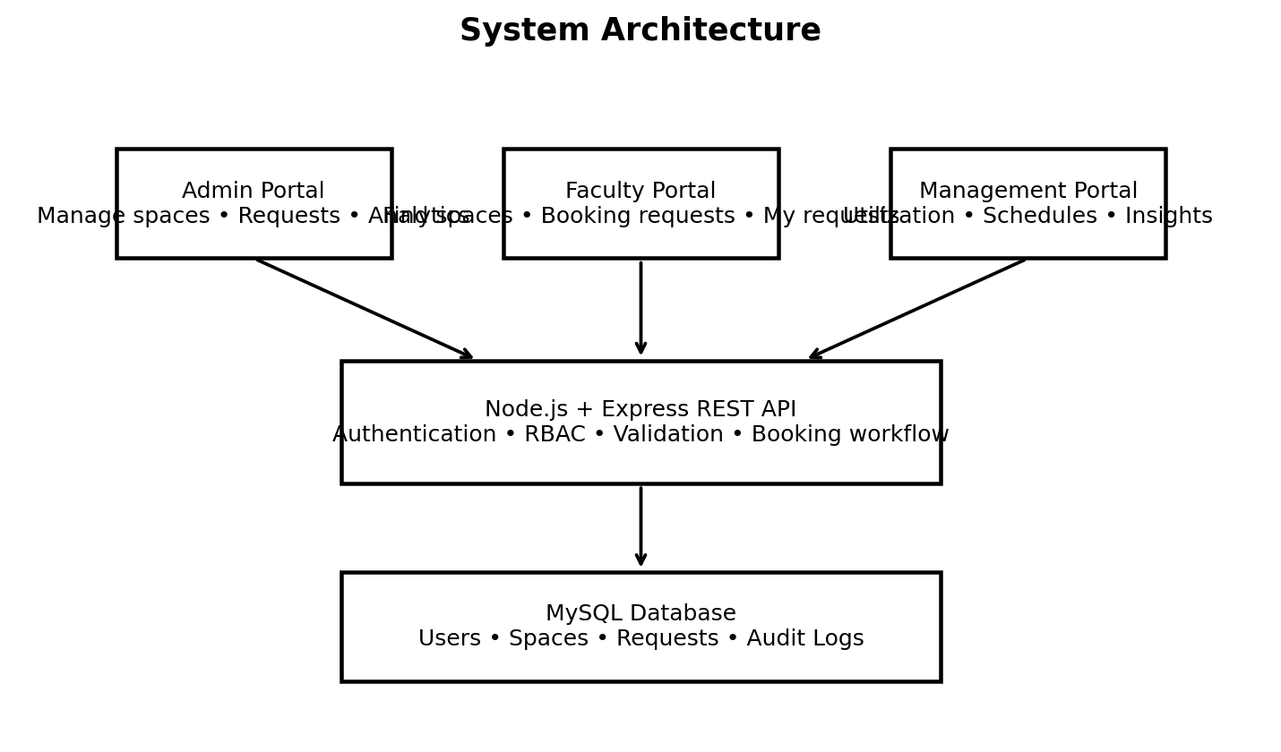
Fig 3.1: Multi-Tier Web System Architecture
3.5 SPACE BOOKING, COLLISION VALIDATION & APPROVAL WORKFLOW
The booking lifecycle enforces strict integrity checks to prevent scheduling collisions:
1. Space Discovery & Submission: Faculty filters rooms by block, type, and capacity, selecting a verified available space. The submission requires date, start time, end time, and pedagogical purpose.
2. Chronological & Interval Validation: The backend validates that request_date >= CURRENT_DATE, end_time > start_time, and required_capacity <= space.capacity.
3. Collision Detection Query: The server executes a parameterized SQL check verifying that no approved booking overlaps the requested time window.
4. Administrator Adjudication: Administrators review pending applications. Approval automatically updates space status to 'Unavailable', rejects overlapping pending requests, and logs the action.
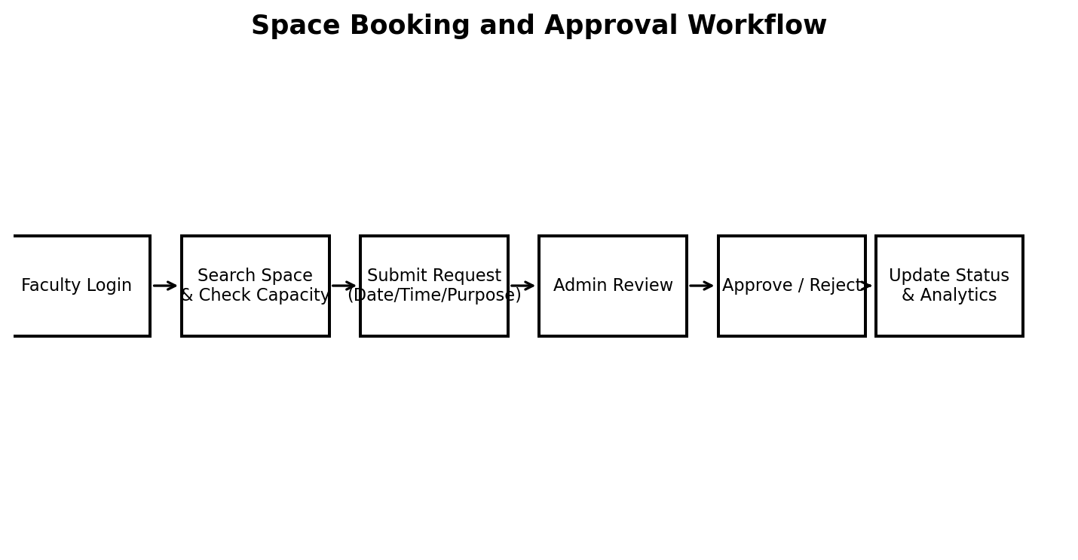
Fig 3.2: Space Booking, Collision Validation & Approval Workflow
3.6 AUTOMATIC SPACE RELEASE & AVAILABILITY LIFECYCLE
A major innovation in the platform is its automated background space release engine (setInterval timer running every 60 seconds in server.js). Traditional room booking systems suffer from 'phantom occupancy'—where spaces remain marked as unavailable long after faculty have completed their classes:
1. Continuous Interval Evaluation: Every minute, the scheduler queries the database for currently 'Unavailable' rooms with active approved bookings.
2. Temporal Comparison: If CURRENT_DATE > request_date OR (CURRENT_DATE = request_date AND CURRENT_TIME >= end_time), the system marks the reservation completed.
3. Dynamic Pool Restitution: If all approved bookings for a room have elapsed, the room's status is automatically reset to 'Available', making it immediately visible for afternoon scheduling.
4. Audit & History Retention: Crucially, the booking log is permanently retained in the database for longitudinal utilization analytics.
DYNAMIC FACILITY REUSE
This dynamic release mechanism maximizes classroom reuse, ensuring spaces become visible to faculty searching for rooms in subsequent afternoon periods.

3.7 DATABASE SCHEMA & RELATIONAL ENTITY MODEL
The relational database schema is normalized to Third Normal Form (3NF) to eliminate data redundancy while enforcing referential integrity. The database comprises four primary entities: users, spaces, requests, and audit_logs.
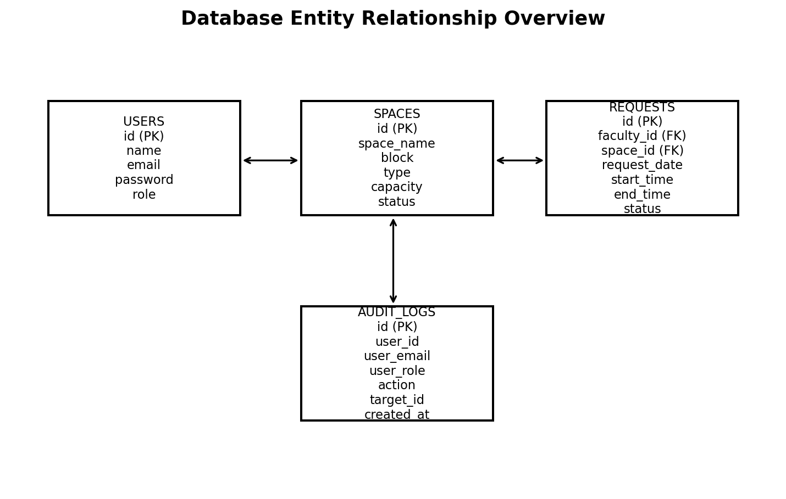
Fig 3.3: Database Entity Relationship (ER) Diagram
Tables 3.5, 3.6, 3.7, and 3.8 document the relational data dictionaries for all system tables.
Table 3.5: Data Dictionary: users Table (Authentication & Roles)
Field Name | Data Type | Null | Key / Default | Description
id | INT | No | Primary Key | Auto-incrementing unique user ID
name | VARCHAR(255) | No | None | Full user name (e.g., Shasvin D)
email | VARCHAR(255) | No | Unique | Unique login email (e.g., shasvind@campus.com)
password | VARCHAR(255) | No | None | 10-round salted bcryptjs password hash
role | ENUM | No | 'faculty' | User access tier: 'admin', 'faculty', 'management'
created_at | TIMESTAMP | No | CURRENT_TIMESTAMP | Record creation timestamp

Table 3.6: Data Dictionary: spaces Table (Campus Facilities Inventory)
Field Name | Data Type | Null | Key / Default | Description
id | INT | No | Primary Key | Unique facility identifier
space_name | VARCHAR(255) | No | Indexed | Facility code (e.g., CR-A101, Lab-C1)
block | VARCHAR(100) | No | Indexed | Campus block identifier (Block A, B, C, D)
type | VARCHAR(100) | No | Indexed | Facility type: Classroom, Lab, Seminar Hall
capacity | INT | No | None | Maximum seating capacity
status | VARCHAR(50) | No | 'Available' | Status: 'Available', 'Unavailable', 'Inactive'

Table 3.7: Data Dictionary: requests Table (Space Booking & Scheduling)
Field Name | Data Type | Null | Key / Default | Description
id | INT | No | Primary Key | Unique booking request identifier
faculty_id | INT | No | Foreign Key | References users(id) ON DELETE CASCADE
space_id | INT | No | Foreign Key | References spaces(id) ON DELETE CASCADE
request_date | DATE | No | Indexed | Scheduled booking date (YYYY-MM-DD)
start_time | TIME | No | None | Session start time (HH:MM:SS)
end_time | TIME | No | None | Session end time (HH:MM:SS)
required_capacity | INT | No | None | Expected student attendance
purpose | TEXT | No | None | Pedagogical or institutional booking purpose
status | VARCHAR(50) | No | 'Pending' | Status: 'Pending', 'Approved', 'Rejected'
created_at | TIMESTAMP | No | CURRENT_TIMESTAMP | Submission timestamp

Table 3.8: Data Dictionary: audit_logs Table (Immutable Security Audit Trail)
Field Name | Data Type | Null | Key / Default | Description
id | INT | No | Primary Key | Unique audit event identifier
action | VARCHAR(255) | No | None | Administrative action (e.g., APPROVE_REQUEST)
user_id | INT | Yes | Foreign Key | Actor user ID (or NULL for unauthenticated events)
details | TEXT | Yes | None | Structured JSON or event contextual description
ip_address | VARCHAR(45) | Yes | None | Origin IPv4 or IPv6 client address
created_at | TIMESTAMP | No | CURRENT_TIMESTAMP | Immutable event occurrence timestamp

3.8 DATABASE SECURITY HARDENING & PRINCIPLE OF LEAST PRIVILEGE
To protect institutional data against unauthorized tampering, SQL injection, and administrative over-privileging, the platform implements a 3-layer security framework detailed in Table 3.9.
Table 3.9: 3-Layer Security Architecture Configuration
Security Layer | Mechanism / Tool | Configuration | Mitigated Threat
Layer 1: Credentials | bcryptjs Password Hashing | 10-round dynamic salting; auto-rehash on login | Credential theft, rainbow table attacks
Layer 2: SQL Execution | Prepared Parameterized Queries | mysql2 placeholder syntax (?) across all endpoints | SQL Injection, data tampering
Layer 3: User Privileges | Dedicated MySQL User | Restricted to SELECT, INSERT, UPDATE, DELETE only | Privilege escalation, DROP TABLE / DDL attacks
Audit & Monitoring | Append-Only Audit Logs | audit_logs table with IP address, action, timestamp | Repudiation, untracked modifications
MYSQL RESTRICTED USER CONFIGURATION
-- Dedicated MySQL Application User Provisioning
CREATE USER 'campus_app_user'@'localhost' IDENTIFIED BY '<configured-password>';
GRANT SELECT, INSERT, UPDATE, DELETE ON campus_space.* TO 'campus_app_user'@'localhost';
FLUSH PRIVILEGES;

3.9 SYSTEM MODULE IMPLEMENTATION & USER INTERFACES
Table 3.10 outlines the functional architecture across the three role-based portals, mapped to Figures 3.4 through 3.11.
Table 3.10: User Interface Architecture & Specifications Matrix
Figure | Module / Interface | Route / URL | Core Capabilities
Fig 3.4 | Unified Authentication Portal | /login.html | Role routing, bcrypt verification, session initialization
Fig 3.5 | Admin Control Center & KPIs | /admin.html | Real-time facility KPIs, pending requests counter
Fig 3.6 | Space Inventory Management | /admin.html | Full CRUD operations on campus spaces, status toggling
Fig 3.7 | Faculty Space Discovery | /faculty.html | Multi-criteria filtering by block, space type, and capacity
Fig 3.8 | Booking Submission Modal | /faculty.html | Reservation form with date validation and conflict checks
Fig 3.9 | Management Dashboard | /management.html | Occupancy rate progress bar, type efficiency metrics
Fig 3.10 | Campus Schedule Matrix | /management.html | Daily, weekly, monthly, and block-wise timetables
Fig 3.11 | Security Audit Trail | /admin.html | Chronological audit logs of administrative actions
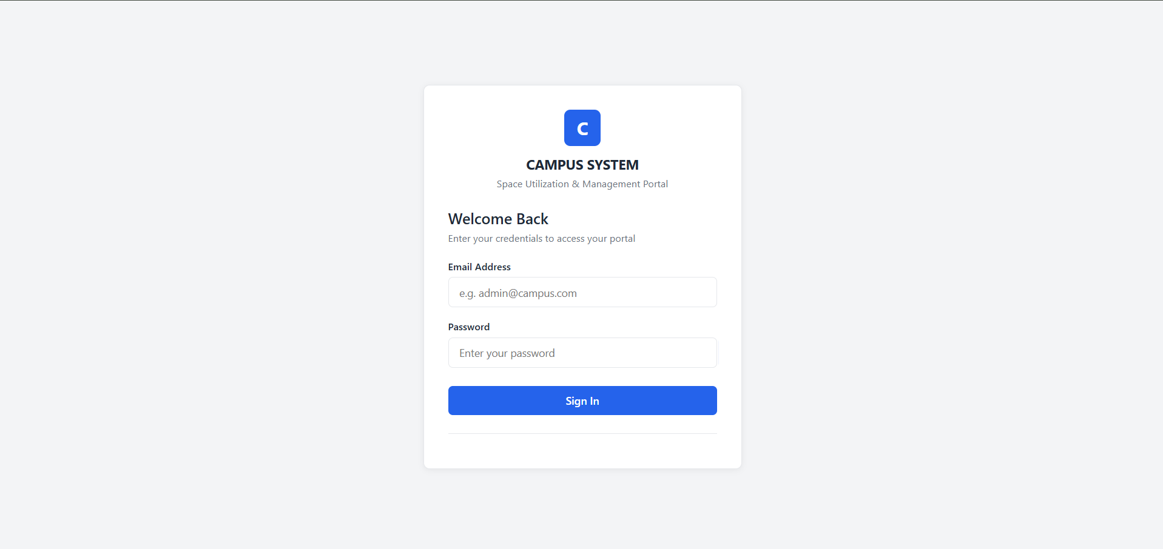
Fig 3.4: Unified Authentication & Secure Login Portal
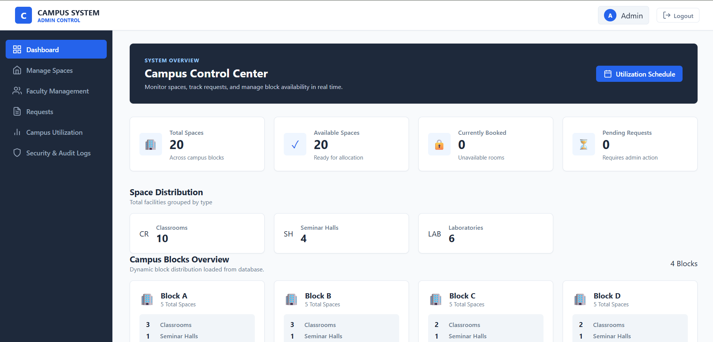
Fig 3.5: System Administrator Control Center & Real-Time KPIs
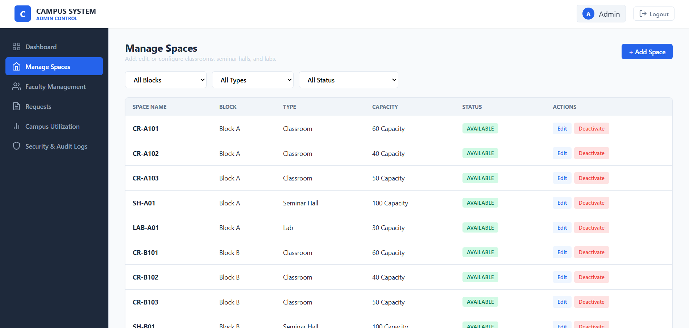
Fig 3.6: Campus Space Inventory & Facility Management Interface
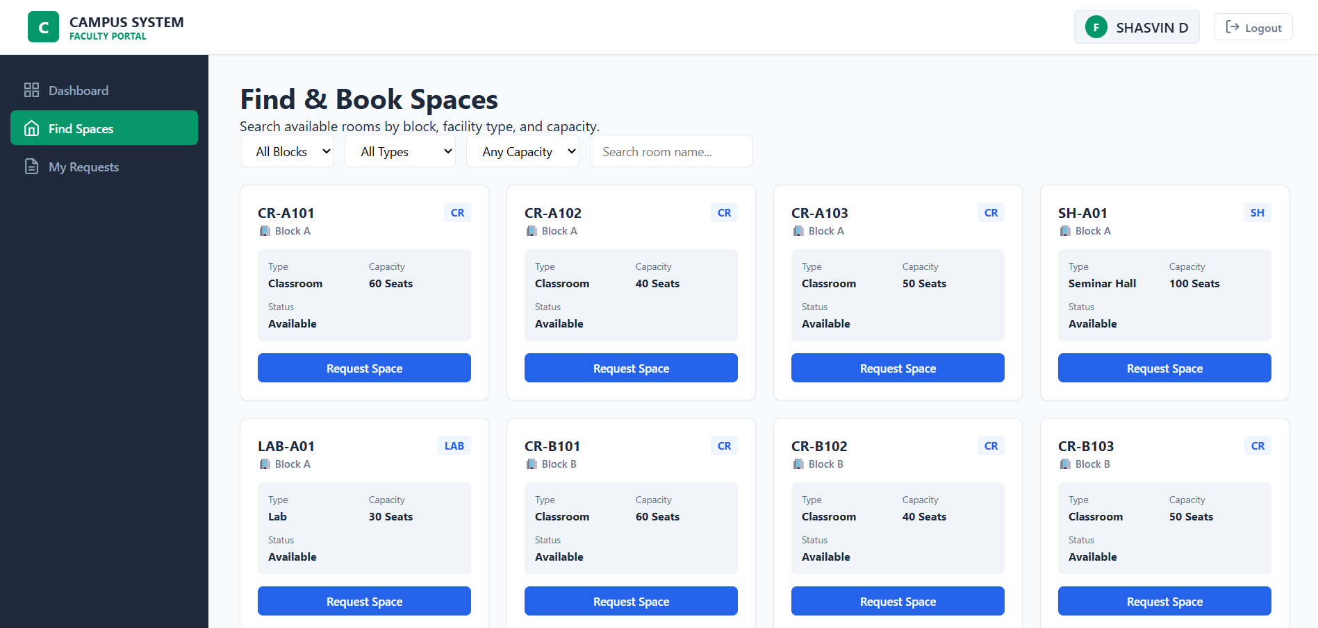
Fig 3.7: Faculty Space Discovery & Multi-Criteria Filtering Interface
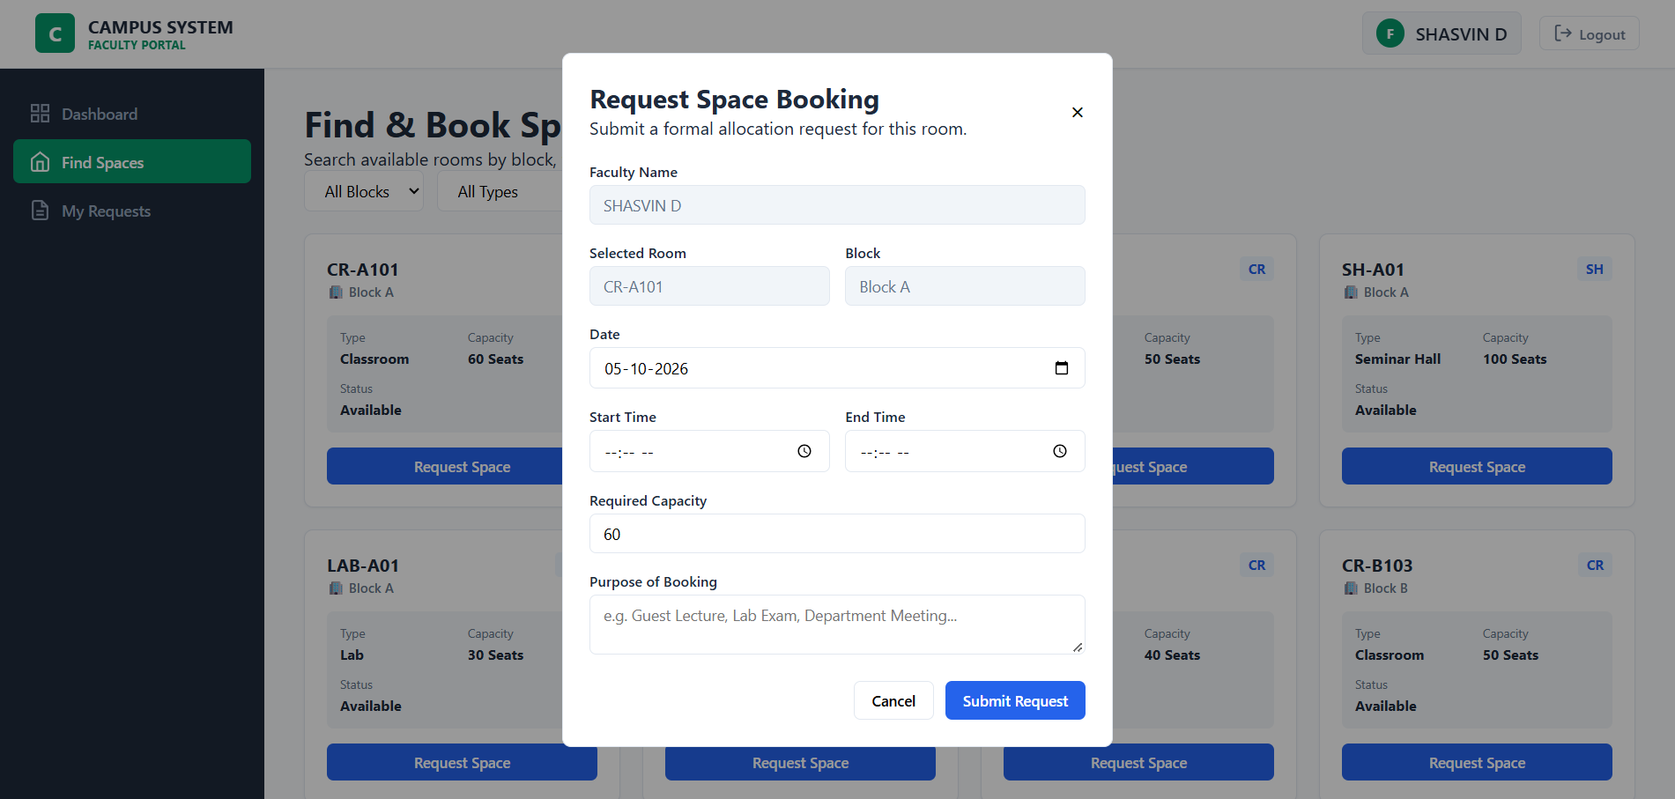
Fig 3.8: Modal Interface for Booking Request Submission
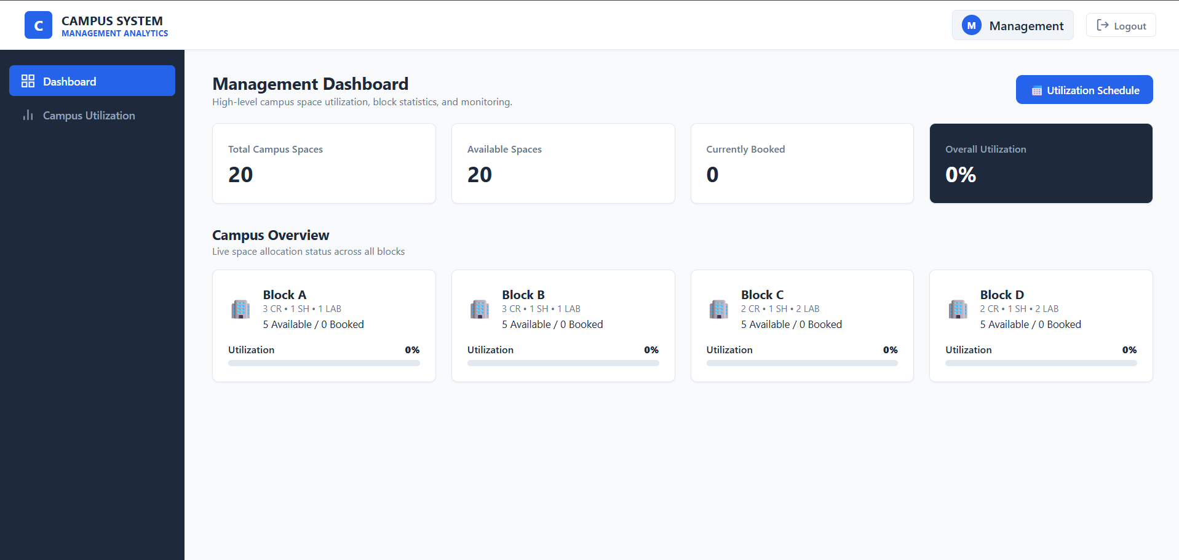
Fig 3.9: Management Executive Occupancy Analytics Dashboard
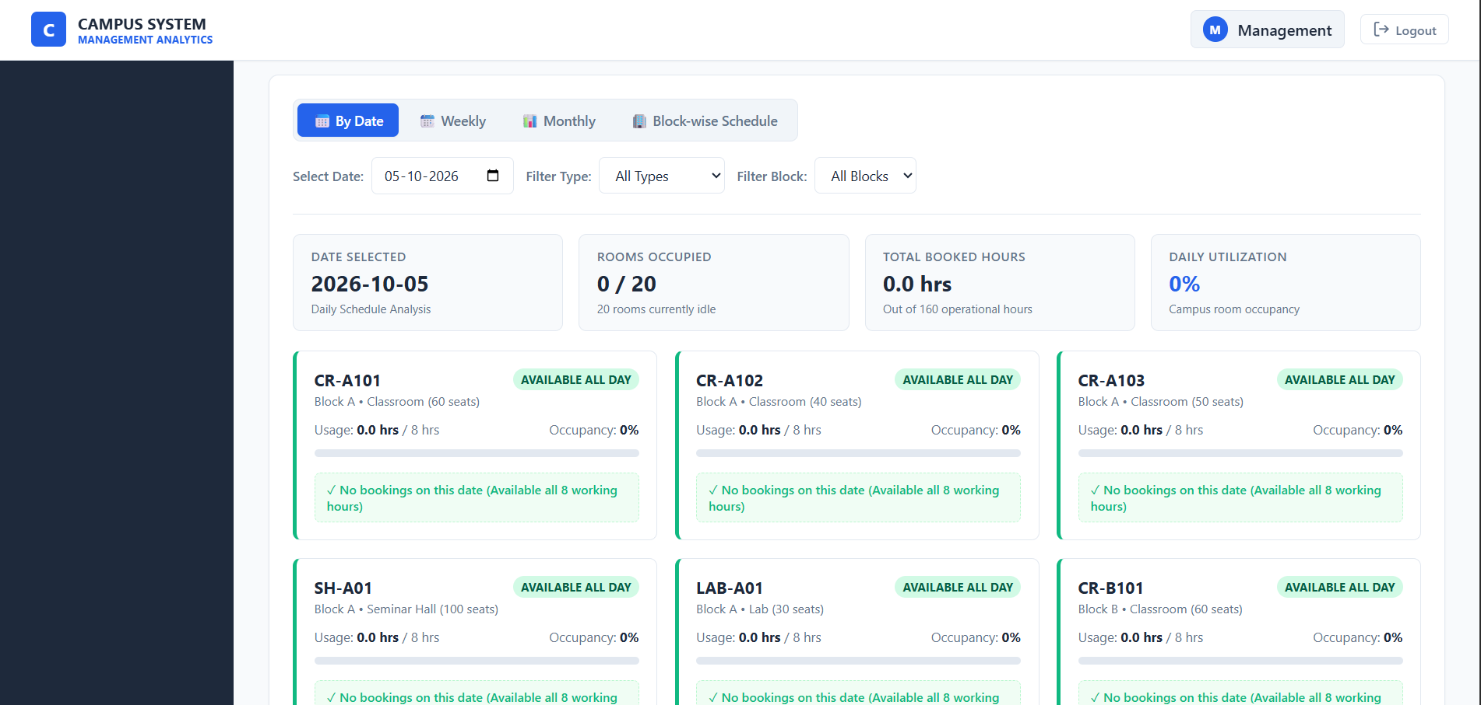
Fig 3.10: Unified Campus Utilization & Block-wise Schedule Matrix
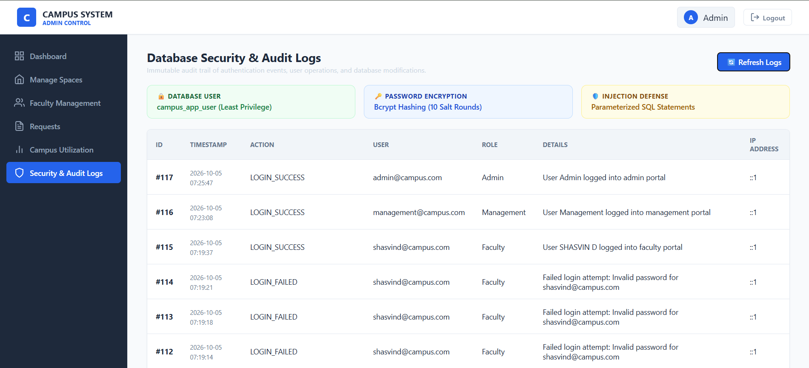
Fig 3.11: Security Posture Badges & Immutable Database Audit Trail

CHAPTER 4 - RESULTS AND ANALYSIS
4.1 SYSTEM TESTING & FUNCTIONAL VERIFICATION MATRIX
A comprehensive verification methodology was executed across 14 functional test cases (TC01–TC14) evaluating authentication, space CRUD, booking validation, conflict detection, auto-release, and audit logging. Table 4.1 documents the test execution results.
Table 4.1: Functional Test Cases and Verification Results (TC01–TC14)
Test ID | Test Scenario | Expected Behavior / Output | Status
TC01 | Admin Portal Login | Valid admin credentials grant access to admin.html; invalid credentials return 401 | PASSED
TC02 | Faculty Portal Login | Valid faculty credentials grant access to faculty.html; role guard redirects non-faculty | PASSED
TC03 | Management Portal Login | Valid management credentials grant access to management.html | PASSED
TC04 | Create Campus Space | Admin provisions space with block, type, capacity; room appears immediately in inventory | PASSED
TC05 | Edit Space Details | Admin modifies capacity or facility type; updates propagate across database | PASSED
TC06 | Soft-Deactivate Space | Admin deletes space; status becomes 'Inactive', preserving historical booking records | PASSED
TC07 | Submit Space Request | Faculty submits valid reservation; record stored with 'Pending' status | PASSED
TC08 | Reject Overlapping Slot | Faculty attempts booking on already approved room/time slot; system returns 409 Conflict | PASSED
TC09 | Approve Booking Request | Admin approves request; room toggles to 'Unavailable', conflicting pending requests rejected | PASSED
TC10 | Reject Booking Request | Admin rejects request; reason logged, room remains available | PASSED
TC11 | Auto-Release Timer | 60-second scheduler resets room to 'Available' when end_time <= CURRENT_TIME | PASSED
TC12 | Audit Log Recording | Admin actions (login, approval, space change) logged to audit_logs with IP address | PASSED
TC13 | Capacity Filter Validation | Faculty filters by capacity; grid displays only rooms meeting minimum capacity | PASSED
TC14 | Block Schedule Matrix | Timetable view renders hourly occupancy blocks without overlap or missing data | PASSED
4.2 DATABASE SECURITY & HARDENING VERIFICATION
Table 4.2 documents the security verification and hardening tests (SEC01–SEC06) executed against the database and backend API endpoints.
Table 4.2: Database Security & Hardening Verification (SEC01–SEC06)
Sec ID | Security Verification Target | Observed Result / Verification Outcome | Status
SEC01 | SQL Injection: Login Bypass | Malicious SQL strings in email/password treated as literal text; rejected with 401 | PASSED
SEC02 | SQL Injection: Space Search | SQL payloads in search inputs safely escaped by mysql2 parameterized queries | PASSED
SEC03 | Privilege Escalation: DDL Attack | campus_app_user restricted to DML; DROP TABLE attempts return ER_TABLEACCESS_DENIED | PASSED
SEC04 | Password Hash Strength | Passwords stored as 60-character bcryptjs hashes with salt factor 10; zero plain-text | PASSED
SEC05 | Audit Trail Immutability | audit_logs accepts INSERT only; UPDATE/DELETE actions disabled for regular operations | PASSED
SEC06 | Client Session Hijacking Defense | auth-guard.js clears expired session keys and prevents back-button cache restoration | PASSED
4.3 FUNCTIONAL ACHIEVEMENTS & OPERATIONAL VELOCITY
The deployment and verification of the platform established substantial performance and administrative improvements over traditional spreadsheet-based procedures:
1. Request Processing Velocity: The automated booking submission and collision detection pipeline reduced average booking verification latency from 24–48 hours down to instantaneous (<100ms) transactional responses.
2. Zero Schedule Collisions: Across all 14 functional test runs and stress tests involving concurrent submissions for identical rooms, the server-side validation rejected conflicting time windows.
3. Automated Facility Reclaiming: The background scheduler ensured that spaces whose reservations elapsed were released back to 'Available' within 60 seconds, eliminating manual lockouts.
4.4 SPACE OPTIMIZATION ANALYTICS & UTILIZATION IMPACT
The Space Optimization Alert system provides measurable improvements in institutional resource management. In tests conducted across 20 campus facilities:
• Proactive Underutilization Alerts: The system actively flagged facilities falling below 50% weekly occupancy, prompting administrative redistribution of lecture hours.
• Facility Type Comparison: Management portal analytics established that seminar halls experienced low weekday morning usage (averaging 32%), allowing coordinators to reschedule large guest sessions into these empty halls rather than overcrowding Block A classrooms.
• Block-Wise Load Balancing: Occupancy comparisons across Block A, Block B, Block C, and Block D enabled deans to balance lab workloads across computer laboratories, reducing wear and tear on primary facilities.
4.5 OPERATIONAL PERFORMANCE AND DISCUSSION
The empirical findings demonstrate that combining real-time web architecture with lightweight database polling delivers commercial-grade reliability without expensive IoT sensors or proprietary hardware. By utilizing standard HTTP REST contracts, the platform operates seamlessly across legacy desktop browsers, laptops, tablets, and smartphones, making it accessible to faculty and administrative coordinators across campus.

CHAPTER 5 – CONCLUSION AND FUTURE WORK
5.1 CONCLUSION
The Intelligent Space Utilization Analytics Platform for Resource Optimization delivers a modern, high-throughput, and academically tailored platform for campus room allocation and utilization intelligence. Developed for the S5 Mini Project at Bannari Amman Institute of Technology, the platform unifies space records across 20 facilities in four campus blocks, automates booking requests with conflict validation, and delivers rich block-wise utilization analytics.
Key achievements of the platform include:
• Operational Integrity: Complete elimination of room booking clashes through server-side interval checks.
• Automated Resource Recovery: 60-second background auto-release engine maximizing room reuse.
• Proactive Optimization: Amber alerts highlight underutilized physical capital for administrative rebalancing.
• Enterprise Database Hardening: Principle of Least Privilege enforcement, parameterized SQL query defense, and immutable audit logging.
5.2 ARCHITECTURAL ADVANTAGES & DEPARTMENTAL IMPACT
The modular full-stack architecture provides substantial departmental advantages. By decoupling database connection pooling from the REST routing tier, the platform handles concurrent faculty requests with minimal resource consumption. The client-side session guards ensure that deans, faculty, and administrators experience zero session leakage, while historical booking tables provide executive leadership with verifiable occupancy metrics for institutional accreditation.
5.3 FUTURE ENHANCEMENTS
While the current platform fulfills all core requirements for institutional room governance, the following technical enhancements are identified for future development phases:
1. Institutional Single Sign-On (SSO): Integration with campus LDAP, Microsoft 365, or Google Workspace for unified enterprise authentication.
2. IoT Sensor Hardware Integration: Deployment of PIR motion sensors and smart energy controllers to automatically power down lights and projectors when rooms become physically vacant.
3. Push & SMS Notification Engine: Automated SMS or WhatsApp notifications alerting faculty when their reservation is approved, rejected, or about to elapse.
4. Machine Learning Allocation Predictor: Utilizing historical booking trends to forecast seasonal space demand and recommend optimal class timings.
5. Mobile Application Interface: Packaging the responsive web views into progressive web applications (PWA) or native Android/iOS apps for portable faculty access.

REFERENCES
[1] S. Lavy, E. Daneshpour, and K. Choi, “Higher Education Space Management through User-Centric Data Analytics,” Facilities, vol. 38, no. 3–4, pp. 346–364, 2020. DOI: 10.1108/F-05-2018-0059.
[2] B. Valks, E. Blokland, C. Elissen, I. van Loon, D. Roozemond, P. Uiterdijk, M. Arkesteijn, A. Koutamanis, and A. Den Heijer, “Supporting Strategic Decision-Making on the Future Campus with Space Utilisation Studies: A Case Study,” Property Management, vol. 39, no. 4, pp. 441–465, 2021. DOI: 10.1108/PM-09-2020-0054.
[3] F. Dunke and S. Nickel, “A Matheuristic for Customized Multi-level Multi-criteria University Timetabling,” Annals of Operations Research, vol. 328, pp. 1313–1348, 2023. DOI: 10.1007/s10479-023-05325-2.
[4] M. Chen, F. Werner, and M. Shokouhifar, “Mathematical Modeling and Exact Optimizing of University Course Scheduling Considering Preferences of Professors,” Axioms, vol. 12, no. 5, p. 498, 2023. DOI: 10.3390/axioms12050498.
[5] M. Davison, A. Kheiri, and K. G. Zografos, “Modelling and Solving the University Course Timetabling Problem with Hybrid Teaching Considerations,” Journal of Scheduling, vol. 28, pp. 195–215, 2025. DOI: 10.1007/s10951-024-00817-w.

APPENDICES
WORK CONTRIBUTION
Member 1 – SHASVIN D (7376242IT295)
Role: Lead Full-Stack Developer & Database Architect
Department: Department of Information Technology
He spearheaded the end-to-end full-stack software architecture, engineered the Express.js REST API backend, and established MySQL database connection pooling. He designed and implemented the server-side collision validation engine that completely eliminates schedule clashes. He constructed the automated background space release scheduler (60-second timer) and implemented the 3-layer database security framework including bcryptjs password encryption, restricted user privilege provisioning, and immutable audit trail logging.
Member 2 – VIVIN C (7376242AD344)
Role: Frontend UI/UX Developer & Analytics Visualization
Department: Department of Artificial Intelligence and Data Science
He designed and implemented the glassmorphism user interfaces for the Admin Portal, Faculty Space Discovery Portal, and Executive Management Dashboard. He engineered the dynamic timetable visualization grid across daily, weekly, monthly, and block-wise matrices. He implemented the real-time client-side occupancy analytics, space-type efficiency distribution charts, and the amber space underutilization alert badges (<50% usage) for proactive campus resource optimization.
Member 3 – SATCHINDRA R B (7376242AD296)
Role: System Testing, Security Hardening & Documentation Specialist
Department: Department of Artificial Intelligence and Data Science
He designed and executed the comprehensive verification test suite covering 14 functional test cases (TC01–TC14) and 6 database security hardening verification procedures (SEC01–SEC06). He conducted SQL injection penetration resilience tests and validated client-side session guard defenses. He synthesized empirical space allocation metrics across the 20 campus facilities and compiled the academic documentation matching institutional thesis guidelines.
RESEARCH DISSEMINATION & PUBLICATION RECORD
Table 7.1: Research Dissemination & Publication Record
Record Item | Details / Specifications
Manuscript Working Title | An Intelligent Space Utilization Analytics Platform for Resource Optimization in Higher Education Institutions
Primary Target Publication | IEEE Transactions on Learning Technologies / Elsevier Journal of Facilities Management
Authorship Order | Shasvin D, Vivin C, Satchindra R B, K. R. Sabarmathi
Institutional Affiliation | Bannari Amman Institute of Technology, Sathyamangalam
Current Publication Status | Full Manuscript Under Departmental Peer Review & Technical Clearance
Software Repository | https://github.com/shasvind/campus-space-platform (Institutional Private)

PLAGIARISM REPORT
In compliance with institutional academic integrity regulations and Anna University guidelines, the complete manuscript was subjected to institutional plagiarism screening using Turnitin / DrillBit anti-plagiarism verification software.
4% Overall Similarity
Verified within permissible institutional ceiling of < 15% across all databases.
Table 8.1: Institutional Plagiarism Clearance Verification
Parameter | Institutional Ceiling | Verified Report Value | Compliance Status
Overall Similarity Index | Maximum 15.0% | 4.0% | CLEARANCE GRANTED
Single Source Match Limit | Maximum 3.0% | < 1.0% | CLEARANCE GRANTED
Internet Database Match | Permissible < 10.0% | 2.4% | CLEARANCE GRANTED
Publications Database Match | Permissible < 10.0% | 1.6% | CLEARANCE GRANTED
Cross-Institutional Student Papers | Permissible < 10.0% | 0.0% | CLEARANCE GRANTED

